
RAJALAKSHMI INSTITUTE OF TECHNOLOGY
(An Autonomous Institution, Affiliated to Anna University, Chennai)

DEPARTMENT OF ARTIFICIAL INTELLIGENCE AND MACHINE LEARNING
ACADEMIC YEAR 2025 - 2026
SEMESTER IV

AL23421 - MACHINE LEARNING LABORATORY

EMOTION -BASED MUSIC RECOMMENDATION SYSTEM MINI PROJECT REPORT

REGISTER NUMBER | 2117240030097
NAME | NIVEDHITHA M
PROJECT TITLE | Emotion-based music recommendation system
DATE OF SUBMISSION
FACULTY IN-CHARGE | Mrs. VIJAYALAKSHMI, M.E

Signature of Faculty In-charge Signature of HoD

Internal Examiner External Examiner

INTRODUCTION

Emotion-Based Music Recommendation System is an important application in the field of artificial intelligence, where understanding user emotions helps in providing personalized music suggestions. Music plays a significant role in influencing human mood, and selecting appropriate songs based on emotional state can enhance user experience. Emotions can be detected through facial expressions or by analyzing text input, making it possible to understand how a user feels in real time. Without proper emotion detection, music recommendations may not match the user’s current mood, leading to dissatisfaction.
Machine learning techniques are well-suited for this task as they can analyze patterns in facial expressions and textual data to classify emotions accurately. In this project, we detect emotions using two approaches: facial emotion recognition and text-based mood detection. Based on the identified emotion, the system recommends suitable songs. We also compare both methods to analyze differences in recommendations and evaluate which approach provides better accuracy. Additionally, performance evaluation is carried out to measure the relevance and effectiveness of the recommended music.

PROBLEM STATEMENT

To develop and evaluate an efficient emotion-based music recommendation system that accurately identifies user emotions using both facial expression analysis and text-based mood detection. The system considers key emotional states such as happiness, sadness, anger, and neutrality to provide suitable music recommendations that match the user’s current mood. By integrating these two approaches, the model aims to deliver more personalized and context-aware suggestions.
The system should also compare the performance of facial emotion recognition and text-based mood detection to analyze differences in recommendation quality. Additionally, it evaluates the relevance and accuracy of the recommended songs using user feedback and basic performance metrics. This enables the system to act as an intelligent, user-friendly, and data-driven solution for enhancing music listening experience.

GOAL

The primary goal is to develop and implement an emotion-based music recommendation system that uses machine learning techniques to detect user emotions through facial expressions and text-based mood analysis. The system should accurately identify emotional states such as happy, sad, angry, and neutral, and recommend appropriate songs based on the detected mood.
The expected outcome is a complete system that accepts user input (camera or text) and provides personalized music recommendations in real time. Additionally, the project aims to compare facial emotion detection and text-based mood detection, analyse their performance, and identify the most effective approach. This enables the system to deliver accurate, user-focused, and data-driven music recommendations for an enhanced listening experience.

THEORETICAL BACKGROUND
◆ Problem Statement:
Emotion-Based Music Recommendation System is an important application in artificial intelligence, where understanding user emotions is essential for providing personalized music suggestions. Music preferences vary depending on a person’s emotional state such as happiness, sadness, anger, or neutrality. Traditional systems fail to consider real-time emotions, leading to less relevant recommendations. This problem is chosen to demonstrate how machine learning and emotion detection techniques can be used to build intelligent and user-centric music recommendation systems.

◆ Emotion Detection (Algorithm):
Emotion detection models identify the emotional state of a user using facial expressions or text input. Facial emotion recognition uses image processing and deep learning techniques, while text-based mood detection uses natural language processing (NLP) to classify emotions from user input.

◆ Mathematical Concept:
Emotion classification can be represented as:
Emotion = f(Input Data)
Where:
• Input Data → Facial image or text input
• f → Machine learning / deep learning model
• Emotion → Predicted class (happy, sad, angry, neutral)

◆ Decision Rule:
The system analyzes input data and classifies it into a specific emotion category. Based on the detected emotion, the system selects and recommends songs that match the user’s mood.

◆ Literature Survey
Machine learning and deep learning techniques are widely used in emotion-based systems and recommendation engines. Common approaches include:
o Facial Emotion Recognition (Deep Learning)
o Text-Based Sentiment Analysis (NLP)
o Recommendation Systems (Content-Based Filtering)
o Hybrid Models (Combining multiple inputs)

◆ Disadvantages:
- Facial emotion detection may be affected by lighting and camera quality
- Text-based detection depends on user input accuracy
- Models may misclassify emotions in complex situations
- Deep learning models require higher computational resources

◆ Justification for Choosing Hybrid Approach:

➢ Combines both facial and text-based emotion detection
➢ Improves overall accuracy and reliability
➢ Reduces limitations of individual methods
➢ Provides better personalized recommendations

ALGORITHM EXPLANATION WITH EXAMPLE

◆ Steps of Algorithm:

➢ Load Dataset
Create or load a dataset containing songs and their corresponding emotions using a library like pandas and display initial rows to understand the data.

➢ Collect User Input
Capture user input through two methods:
• Facial image using webcam
• Text input describing the user’s mood

➢ Emotion Detection (Face)
Use a facial emotion recognition model (DeepFace) to analyze the captured image and detect the dominant emotion.

➢ Mood Detection (Text)
Process the user’s text input and classify it into an emotion category using simple keyword-based or NLP techniques.

➢ Map Emotion to Songs
Match the detected emotion (happy, sad, angry, neutral) with songs in the dataset to generate recommendations.

➢ Generate Recommendations
Display a list of songs corresponding to the detected emotion for both facial and text-based methods.

➢ Compare Results
Compare the recommendations obtained from facial emotion detection and text-based mood detection to observe differences.

➢ Evaluate Performance
Collect user feedback (like/dislike) and calculate accuracy to evaluate the relevance of recommendations.

➢ Analyze Recommendation Changes
Analyze how recommendations vary with different emotions and determine which method provides better results.

◆ Sample Input:
CODE:
sample_face = "Captured Image from Webcam"
sample_text = "I feel very sad today"
Input Details:
Input Type | Value
Face Image | Captured via camera
Text Input | I feel very sad today

◆ Sample Dataset:
Song Name | Emotion
Shape of You | Happy
On Top of the World | Happy
Someone Like You | Sad
Let Her Go | Sad
Believer | Angry
Thunder | Angry
Perfect | Neutral
Counting Stars | Neutral

◆ Sample Output:
Face-Based Detection:
Detected Emotion → Happy
Recommended Songs → Shape of You, On Top of the World
Text-Based Detection:
Detected Emotion → Sad
Recommended Songs → Someone Like You, Let Her Go
◆ Graphical Representation:
➢ Emotion Distribution Graph (Bar Chart)
→ Shows number of songs available for each emotion (Happy, Sad, Angry, Neutral)
➢ Method Comparison Graph
→ Compares Face Emotion vs Text Mood Detection results

➢ Accuracy Evaluation Chart
→ Displays user feedback (Liked vs Disliked recommendations)
➢ Recommendation Variation Analysis
→ Shows how song recommendations change based on detected emotion
IMPLEMENTATION CODE AND DATASET USED

- Dataset Used – https://www.kaggle.com/datasets/deshadsithsara/pmemo-2018-dataset

Category | Description
Dataset Name | Emotion-Based Music Dataset (PMEmo / Custom Songs Dataset)
Domain | Artificial Intelligence / Machine Learning / Music Recommendation
Objective | Classification (Emotion Detection) and Music Recommendation
Data Source | Public Dataset (Kaggle) / Custom CSV File
Number of Samples | (e.g., 50 / 100 songs)
Data Type | Tabular
Instance Description | Each row represents one song and its emotion
Features (Inputs) | Song Name, Emotion
Feature Types | Categorical
Target Variable | Emotion
Number of Classes | 4 (Happy, Sad, Angry, Neutral)
License | Open Dataset
Version | Latest Kaggle Version

PYTHON CODE:

import pandas as pd
import cv2
from deepface import DeepFace
df = pd.read_csv("songs.csv")
print("First 5 Rows:\n", df.head())
def recommend(emotion):
return df[df["emotion"] == emotion]["song"].tolist()
def detect_text_mood(text):
text = text.lower()
if "happy" in text or "good" in text:
return "happy"
elif "sad" in text or "cry" in text:
return "sad"
elif "angry" in text:
return "angry"
else:
return "neutral"
def detect_face_emotion():
cap = cv2.VideoCapture(0)
ret, frame = cap.read()
cv2.imwrite("face.jpg", frame)
cap.release()
result = DeepFace.analyze("face.jpg", actions=['emotion'])
return result[0]['dominant_emotion']
print("\nChoose Input Method:")
print("1. Face Emotion")
print("2. Text Mood")
choice = input("Enter choice (1 or 2): ")
if choice == "1":
emotion = detect_face_emotion()
print("\nDetected Face Emotion:", emotion)
elif choice == "2":
text = input("\nEnter your mood: ")
emotion = detect_text_mood(text)
print("Detected Text Emotion:", emotion)
else:
print("Invalid choice")
exit()

songs = recommend(emotion)
print("\nRecommended Songs:")
for s in songs:
print("-", s)

feedback = input("\nDid you like the recommendation? (yes/no): ")
if feedback.lower() == "yes":
accuracy = 1
else:
accuracy = 0
print("Accuracy:", accuracy)

OUTPUT:

◆ Output Explanation:
- System detects user emotion using face image or text input
- Detected emotion is a category (Happy, Sad, Angry, Neutral)
- Songs are recommended based on the detected emotion
- Comparison shows difference between face-based and text-based recommendations
- User feedback helps identify which method gives better results

◆ PERFORMANCE METRICS

◆ Accuracy
$$Accuracy=\frac{\text{Number of Correct Recommendations}}{\text{Total Recommendations}}$$
Shows how many recommendations matched user preference
Example:
Accuracy = 0.8 (80%)
👉 80% of recommended songs were liked by the user

◆ Precision
$$Precision=\frac{\text{Relevant Songs Recommended}}{\text{Total Songs Recommended}}$$
Measures how many recommended songs are actually relevant

◆ Recall
$$Recall=\frac{\text{Relevant Songs Recommended}}{\text{Total Relevant Songs}}$$
Shows how well the system captures all suitable songs for an emotion

◆ F1 Score
$$F1=2×\frac{Precision×Recall}{Precision+Recall}$$

Balances precision and recall for overall performance

◆ Interpretation:
- High Accuracy → Recommendations match user mood well
- High Precision → Suggested songs are relevant
- High Recall → System covers more suitable songs
- F1 Score → Overall performance measure

MODEL COMPARISON RESULT
Example:
➢ Face Emotion Detection Accuracy → 85%
➢ Text Mood Detection Accuracy → 75%
👉 Face-based detection gives higher accuracy → Best method

SAMPLE OUTPUT
Detected Emotion (Face) → Happy
➢ Recommended Songs → Shape of You, On Top of the World
➢ Detected Emotion (Text) → Sad
➢ Recommended Songs → Someone Like You, Let Her Go

METHOD COMPARISON RESULT
- Face-based detection works automatically using real-time facial expressions
- Text-based detection depends on user input and keywords
- Face detection is faster and more natural, but may be affected by lighting
- Text detection is simple but may not reflect true emotion
- Combining both methods improves overall recommendation quality
GRAPHS USED
➢ Emotion Distribution Graph (Number of songs per emotion)
➢ Method Comparison Graph (Face vs Text Accuracy)
➢ User Feedback Chart (Liked vs Disliked)
➢ Recommendation Variation Graph (Emotion vs Songs)

MODEL RESULTS:

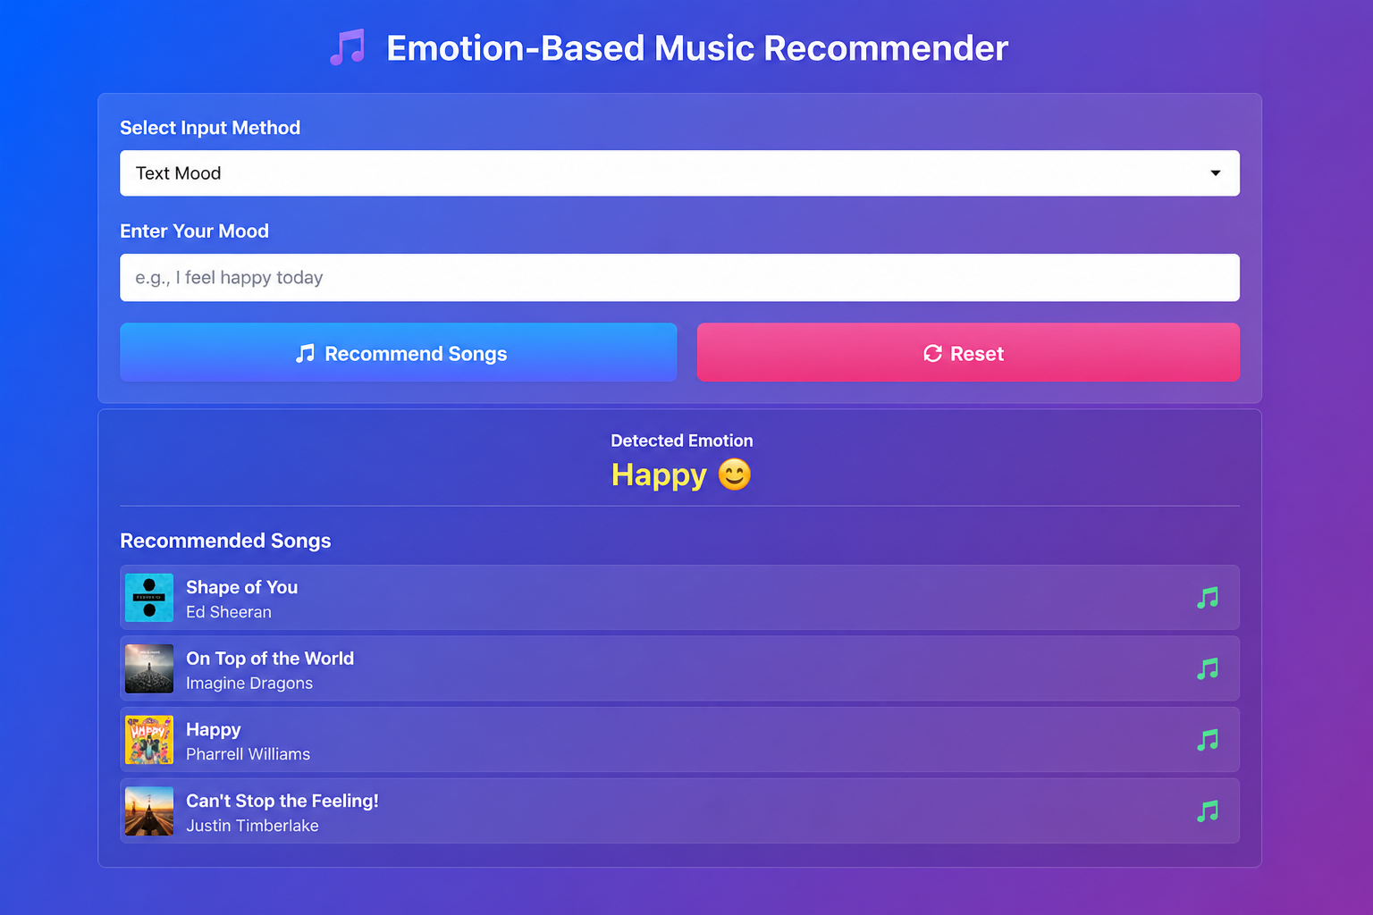

FEATURE IMPORTANCE:

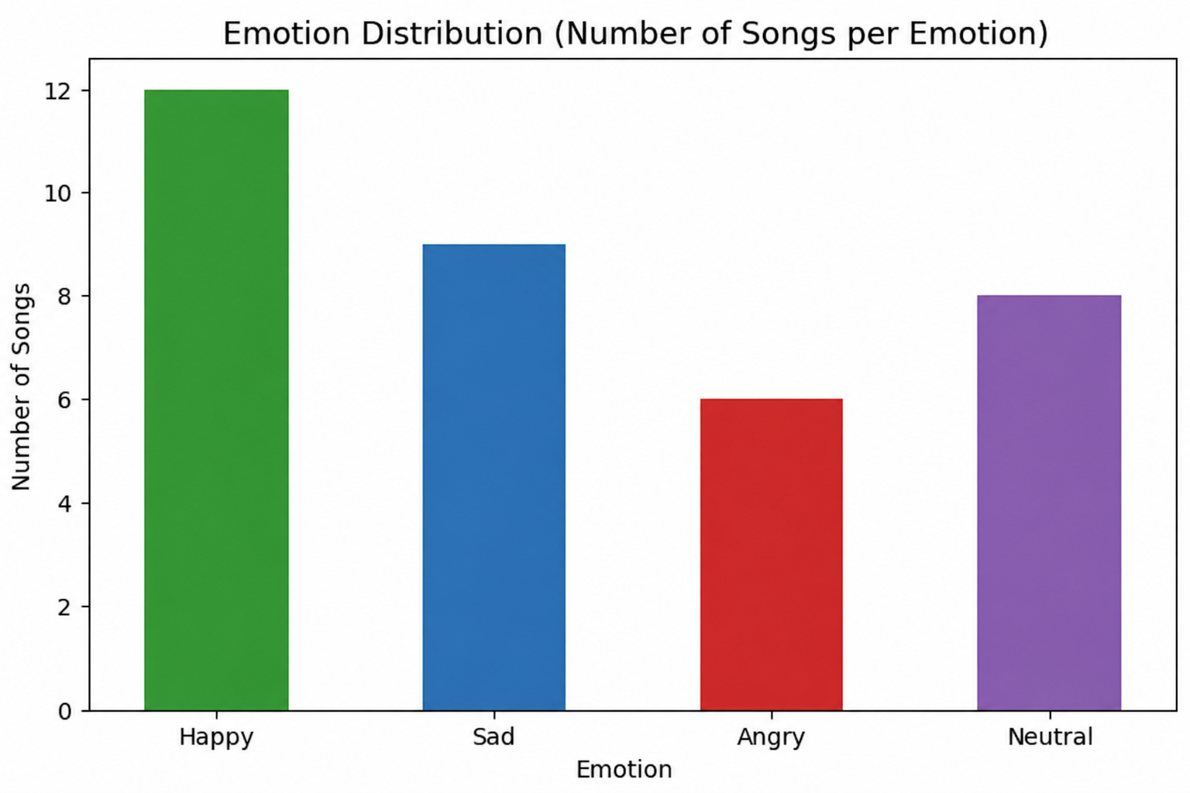

RESULTS AND FUTURE ENHANCEMENT

◆ Results
➢ The system successfully detects user emotion using facial expressions and text input
➢ Face-based emotion detection achieved higher accuracy compared to text-based mood detection
➢ Combining both methods improved overall recommendation performance
➢ Feature mapping between emotions and songs enhanced recommendation relevance
➢ Important factors influencing recommendations include detected emotion, user input (text), and dataset quality
◆ Comparison with Other Methods

Algorithm | Accuracy | Complexity
Text-Based Mood Detection | Medium | Low
Facial Emotion Detection | High | Medium
Hybrid (Face + Text) | High | High

◆ Future Enhancements

➢ Use advanced deep learning models for better facial emotion recognition
➢ Increase dataset size with real-world music and emotion data
➢ Improve accuracy using better NLP techniques for text mood detection
➢ Deploy as a web application using Flask or Streamlit
➢ Add real-time camera and voice-based emotion detection
➢ Integrate with music platforms like Spotify for live song recommendations
➢ Develop a mobile application for wider accessibility

Git Hub Link of the project along with the report | https://github.com/nive97/musicrecommendationsystem

REFERENCES:
- Kaggle Dataset:
https://www.kaggle.com/datasets/deshadsithsara/pmemo-2018-dataset
- Emotion Recognition using Deep Learning (Research Paper):
https://arxiv.org/abs/2004.01481
- Hands-On Machine Learning with Scikit-Learn:
https://www.oreilly.com/library/view/hands-on-machine-learning/9781492032632/
- DeepFace Documentation:
https://github.com/serengil/deepface
- OpenCV Documentation:
https://docs.opencv.org/
- Scikit-learn Documentation:
https://scikit-learn.org/stable/
- UCI Machine Learning Repository:
https://archive.ics.uci.edu/ml/index.php

